**KUBERNETES TASK – 1 (SETUP)**

**1) Setup Minikube in your local machine.**

* Started minikube in virtual studio code
* To check Ip address

>>>minikube ip

* To login to our minikube

>>> minikube ssh

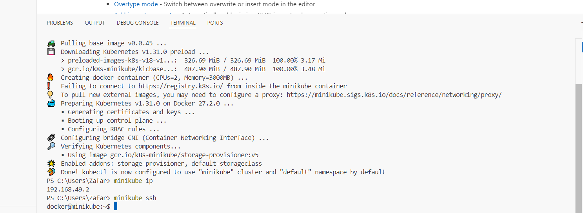

* To check the minikube image

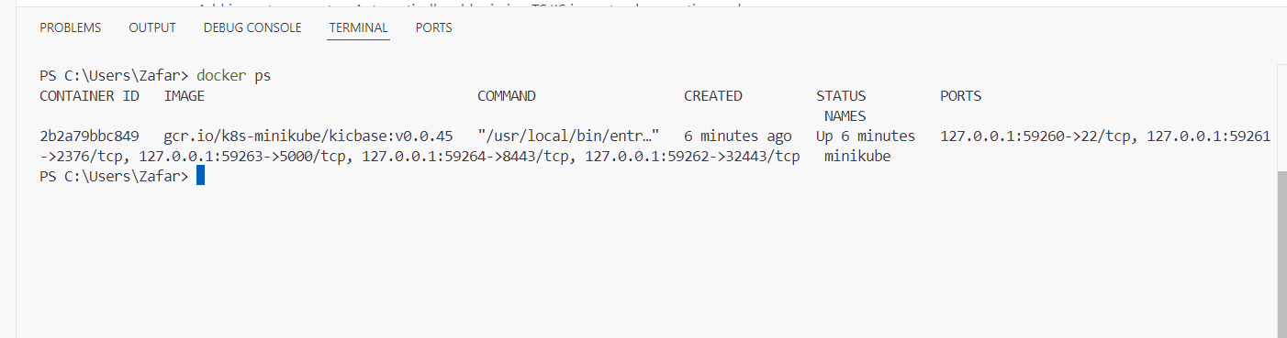

**2) Setup k8s master and two worker nodes on ubuntu.**

* Creating 3 instances using ubuntu image
* Instance type is - t2.medium
* Ami is ubuntu
* Change the hostname for better understanding
* For master – master
* For worker 1 – worker01
* For worker2 – worker02
* sudo vi /etc/hostname
* then restart the instance

>>**master:**

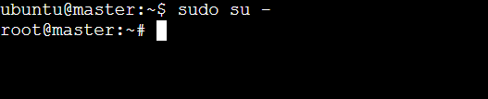

**>>Worker-01:**

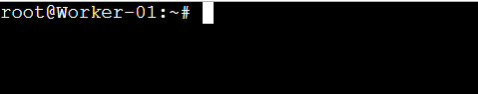

**>> Worker-02:**

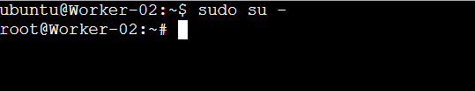

**Set up the IPV4 bridge on all nodes**

cat <<EOF | sudo tee /etc/modules-load.d/k8s.conf

overlay

br_netfilter

EOF

sudo modprobe overlay

sudo modprobe br_netfilter

# sysctl params required by setup, params persist across reboots

cat <<EOF | sudo tee /etc/sysctl.d/k8s.conf

net.bridge.bridge-nf-call-iptables = 1

net.bridge.bridge-nf-call-ip6tables = 1

net.ipv4.ip_forward = 1

EOF

**>> kubectl get nodes**

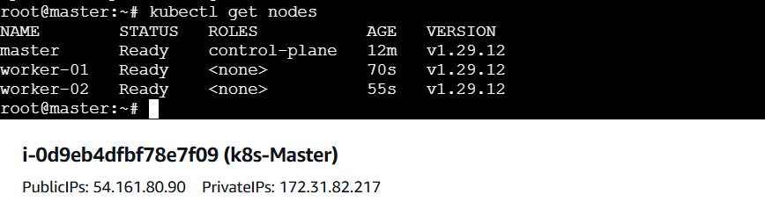

**3) Run one nginx pod.**

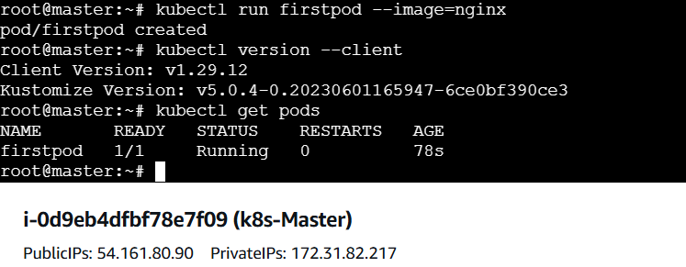

**4) Mugup Master and slave components on k8s.**

Api server

Etcd

Scheduler

Controller manager

Container runtime

Kubelet

KubeProxy